


Yearly Overview
Computing

Year 1
Autumn 1  Basic iPad skills/ keeping ourselves safe | Spring 1  Beebot Explorers | Summer 1  Digital painting
How can I use technology safely? | Can I code a robot? | How do I use technology to create artwork?
 | 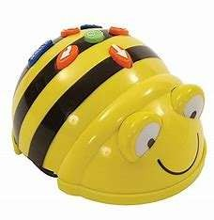 | 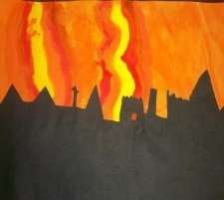
Year 2
Autumn 1  Basic iPad skills/ keeping ourselves safe  How can I use technology safely? | Spring 1  Fundamentals in coding  How can I make a computer programme more efficient?  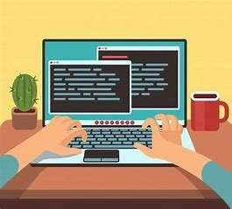 | Summer 1  Art attack  Can I take and edit my own photographs?  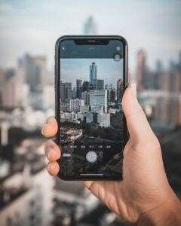

Year 3
Autumn 1 | Spring 1 | Summer 1
Basic iPad skills/ keeping ourselves safe | Joke book sequence  How can I use different functions to programme a sequence? | Animation
How can I use technology safely? |  | Can I create a stop-time
 | 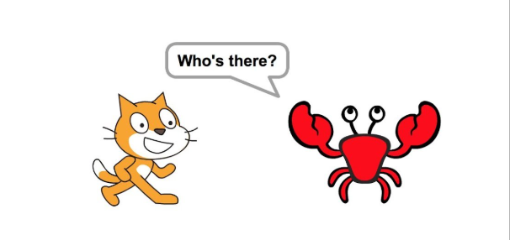 | animation?  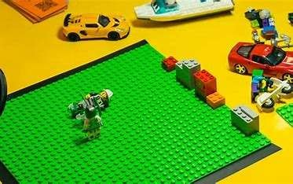
Year 4
Autumn 1  Basic iPad skills/ keeping ourselves safe  How can I use technology safely? | Spring 1  Repetition in shapes  Why should loops be used in code? | Summer 1  Top Trumps  Can I edit images to create my own mythical beast?
 | 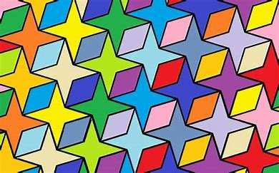 | 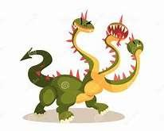




Yearly Overview
Computing

